Lab 5.1 Setup Apache Web Server Using Ansible

This section will guide you to:

Setup apache web server using Ansible

This lab has four sub-sections:

* + 1. Install Ansible on Ubuntu
    2. Establish connectivity between ansible controller and node machine
    3. Write Ansible YAML script to install ansible software
    4. Run Ansible YAML script

**Step 5.1.1:** Install Ansible on Ubuntu

Use the below commands on Ubuntu system to install ansible software.

sudo apt-get install software-properties-common

sudo apt-add-repository ppa:ansible/ansible

sudo apt-get update

sudo apt-get install ansible

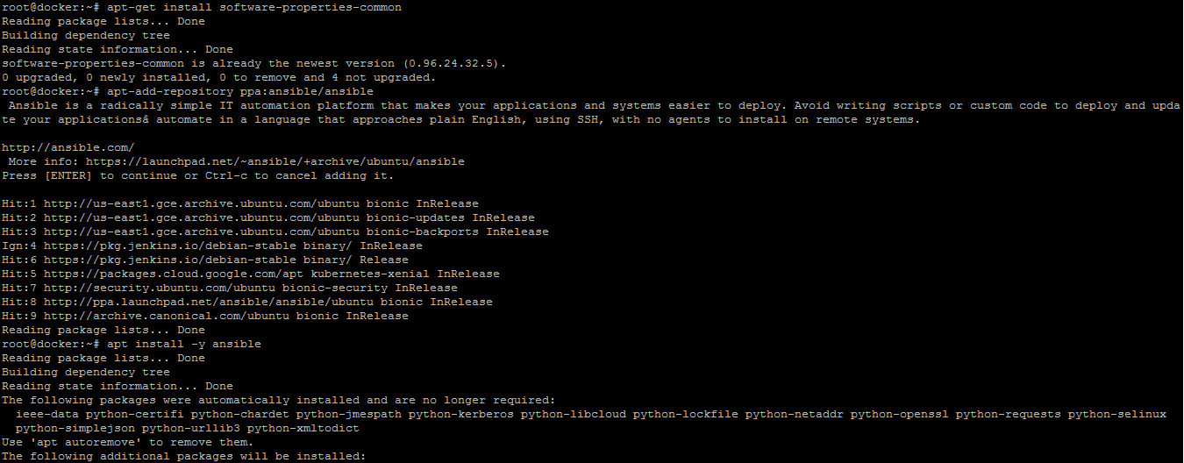

Establish SSH key pair in linux system to have SSH connectivity with localhost using the following commands:

ssh-keygen -t rsa

cat .ssh/id_rsa.pub >> .ssh/authorized_keys

ssh localhost “date”

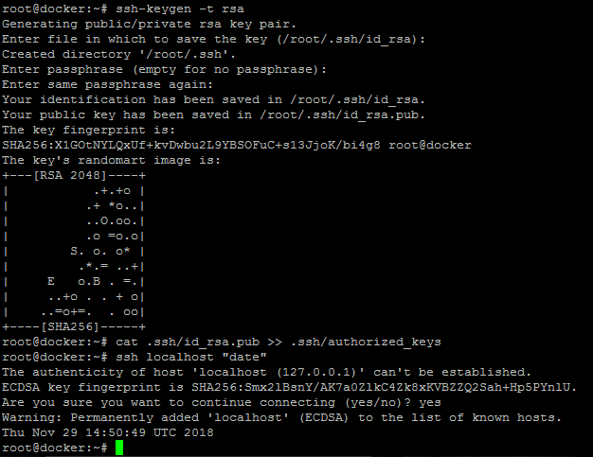

Now, add the host localhost in ansible host file /etc/ansible/hosts.

sudo vi /etc/ansible/hosts

When the file opens, add the following content:

[webservers]

localhost

Create hosts inventory file as per below steps:

Once that is done, validate using Ansible command:

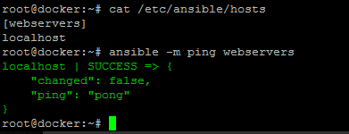

**Step 5.1.2:** Establish connectivity between Ansible controller and node machine

execute the below command to validate host inventory file.

ansible –m ping webservers



**Step 5.1.3:** Write Ansible YAML script to install Ansible software

Once connectivity is established, add the following code in the apache.yaml file and proceed with execution.

sudo vi apache2.yaml

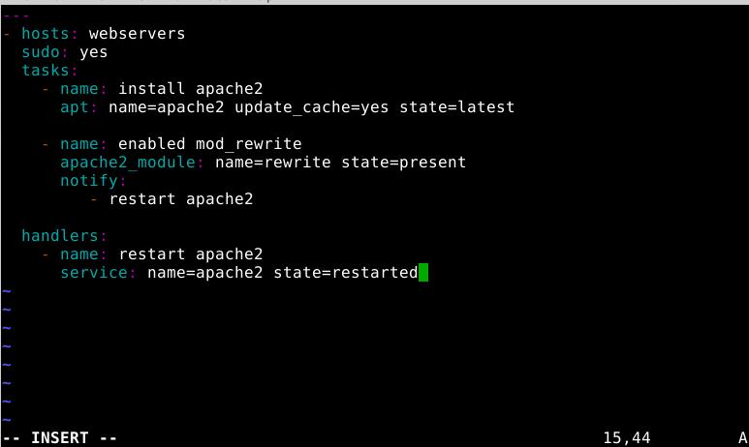

**Step 5.1.4:** Run Ansible YAML script

Run apache.yaml file using below command:

ansible-playbook apache2.yaml

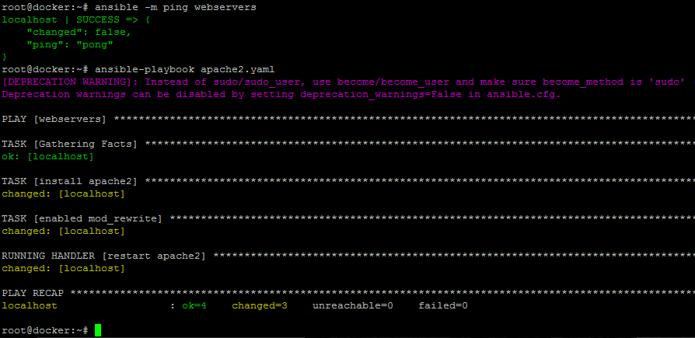

Validate installation using the command:

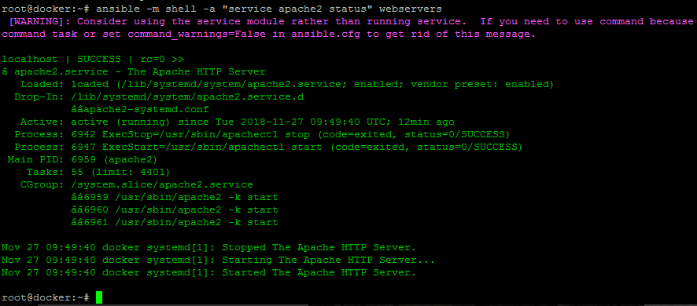ansible -m shell -a "service apache2 status" webservers